**Apparel Industry Analysis**

**Andi Wang 29916046, Jack Yu 92200294, Reshum Zubair 91807925**

**I. Introduction**

The focus of this project is on the **apparel and accessory stores industry sector**, which plays a significant role in the global economy and our life. This sector includes companies involved in the retail of clothing, shoes, and accessories, serving a wide range of consumers across various geographical regions. Over the past few decades, this industry has experienced significant changes due to shifting consumer preferences, economic conditions, and global trends. Our group selected this sector due to its dynamic nature and the availability of extensive data from various retailers and brands that enables meaningful analysis of key financial and operational metrics.

1. **Objective**

The primary objective of this project is to conduct a comprehensive analysis of the public firms within this industry, using both quantitative data and NLP.   
  
**2. Methodology**   
  
In our preliminary analysis, we identified two major events that significantly impacted the Apparel and Accessory Stores industry. The **2008 financial crisis** led to a sharp decline in consumer spending, which heavily affected retailers' revenues and stock prices. Similarly, the **COVID 19 pandemic** in 2020 caused unprecedented disruptions to the global supply chain and consumer behavior, resulting in a considerable drop in sales and stock prices for many firms within this sector, e.g. GAP, Nordstrom.

1. **Techniques and Tools**

Through **data filtering, statistical analysis, and NLP techniques** including keyword analysis and word embeddings, we explored general historical trends within the industry and provided actionable insights into how firms in this sector can navigate through future challenges.

**II. Quantitative Analysis of the Apparel Industry**

1. **Industry data synopsis**

We filtered required the data set based on its industry code, starting with ‘56’, and identified key descriptive features:

* 1. The number of unique years in the dataset is 27,ranging from 1994 to 2020.
  2. There were 105 unique firms in the filtered dataset.
  3. 11 firms in the filtered dataset had records for all 27 years from 1994-2020. The rest of the firms either went private or bankrupt or had their IPO later that 1994.

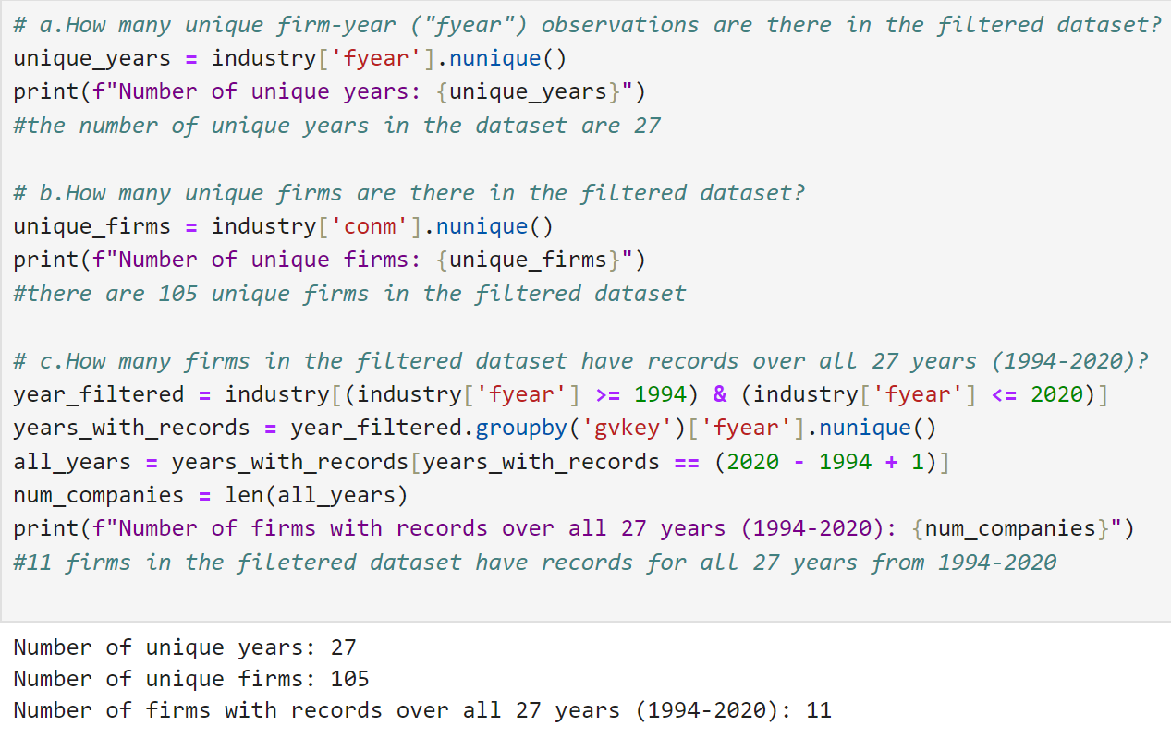

1. **Descriptive analysis**

To understand the general distribution and historical trend of the apparel industry, we used the following key metrics to conduct a descriptive analysis on their financial and operational performances.

* 1. We identified the top 10 firms with highest stock price in 2020, in the filtered dataset.

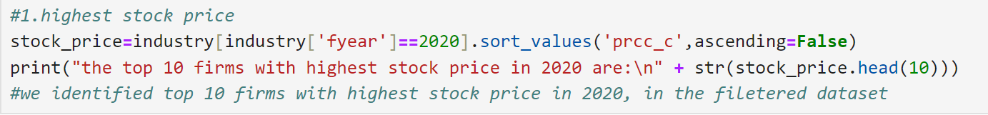

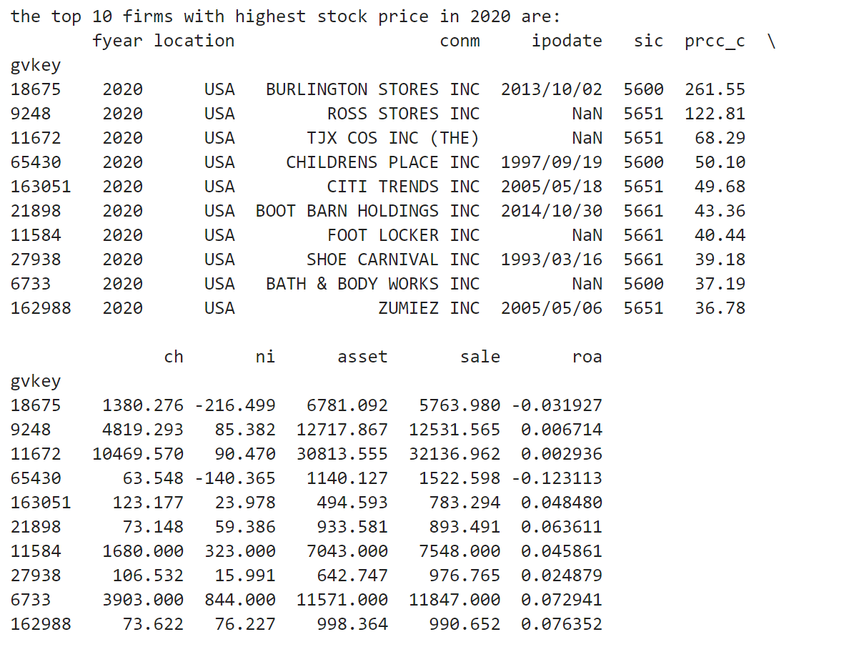

* 1. We identified the top 10 firms with the highest sales in the entire history of dataset.

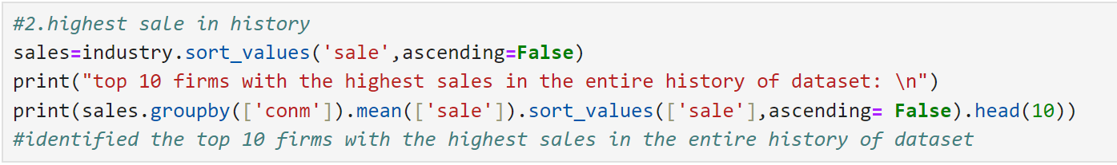

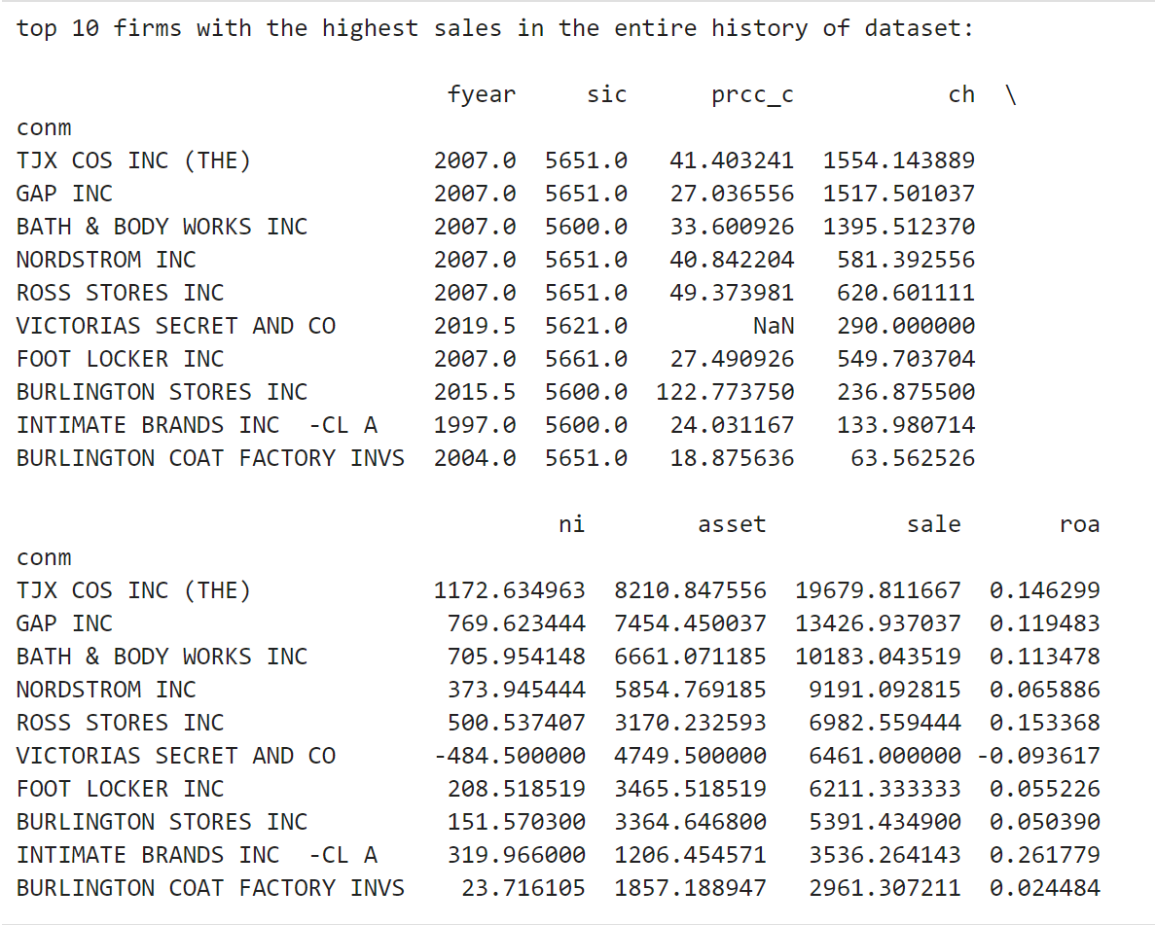

* 1. We identified geographical distributions of all firms, showing that these firms in the dataset only located in USA and Canada.

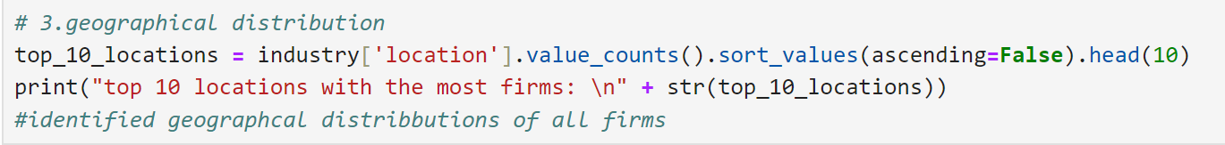

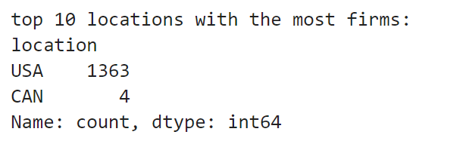

* 1. We plotted the average stock price line chart over the years. Overall, the stock price showed an upward trend, except for the year 2008, where the stock price dipped to USD9.07 due to the financial crisis. The stock price recovered quickly and peaked in the year 2020(final year) in dataset at USD 38.32.

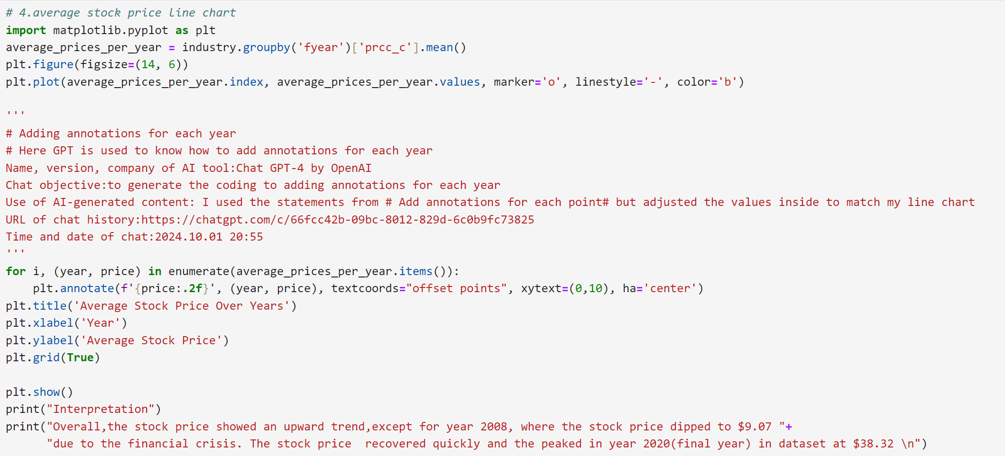

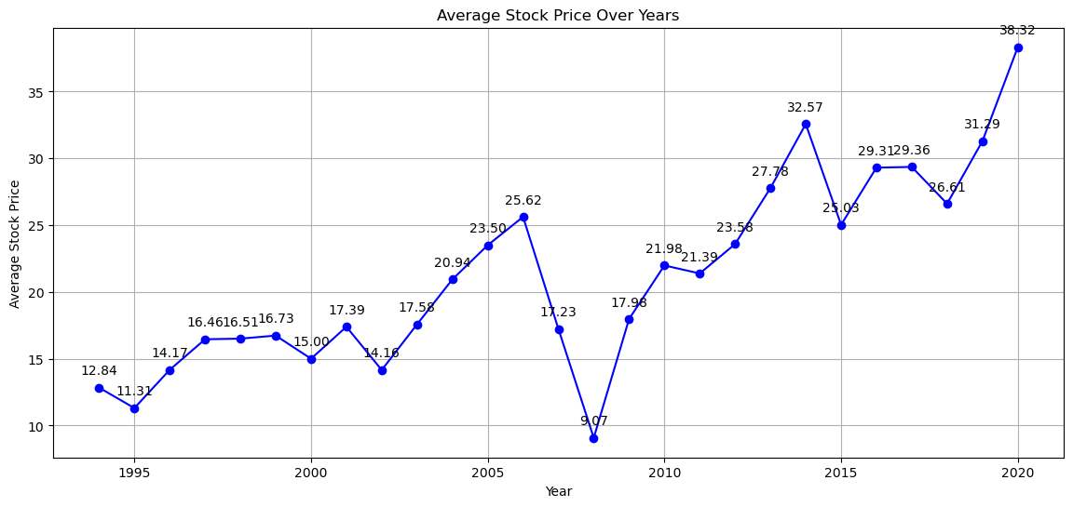

* 1. We found that INCA DESIGNS INC took the hardest hit in the financial crisis heading to its bankruptcy in the same year¹, with a 99.98% drop in stock price.



* 1. We plotted the average Return on Assets (ROA) for the firms located in the “USA” across the years. The ROA for the apparel industry fluctuated around its mean of 3% The ROA was significantly weighed down in 2020 by few underperforming firms like GAP (probably because of Covid!) .

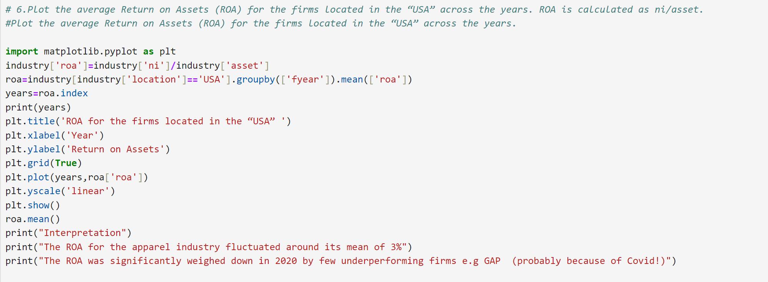

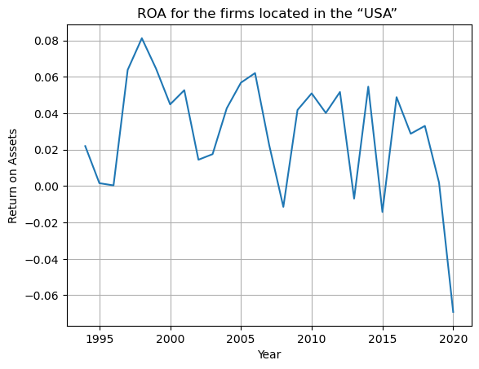

III. **Text Analysis**

1. Text cleaning
   1. Lowercasing: All the text was converted to lowercase to ensure uniformity.
   2. Removing punctuation: Punctuation marks such as commas, periods, question marks, and exclamation points were removed.
   3. Removing stop words: We utilized the English stop words list from NLTK to identify and eliminate these words, focusing on retaining only the more informative words.

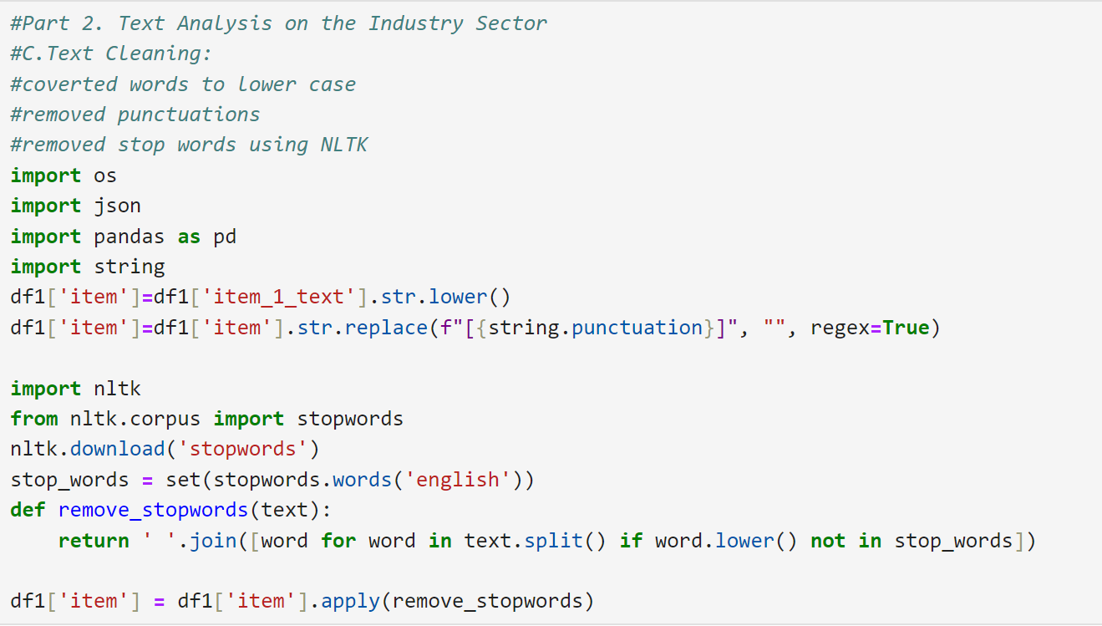

* 1. Inner-joining datasets: we merged the datasets into a holistic one with financial data and 10-K text data.
  2. Possible improvement: in the future, stemming and lemmatization can also be applied to the text cleaning process to combine expressions like firm and firms (singular and plural forms)

1. Keyword analysis and word clouds
   1. We conducted keyword analysis based on two approaches, word count and TF-IDF score.

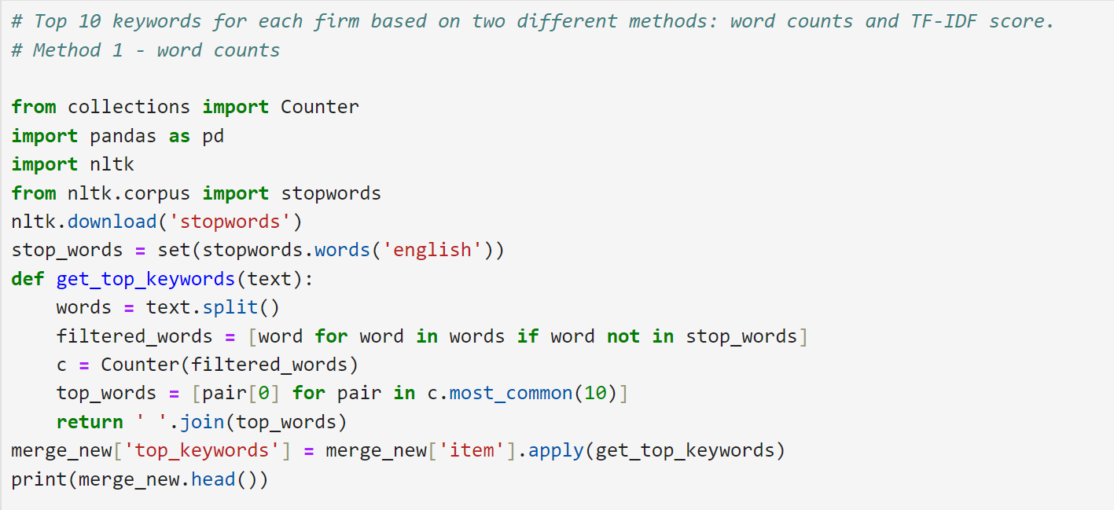

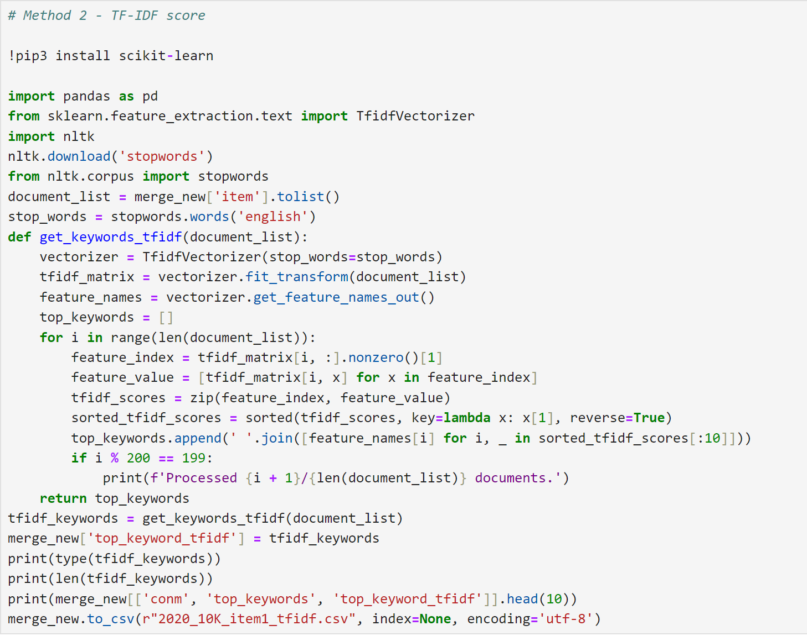

* 1. Some most frequently mentioned keywords were 'Stores', 'Sales', 'Customers' and 'Merchandise' which indicated a highly consumer-centric focus of the apparel industry (makes sense!)

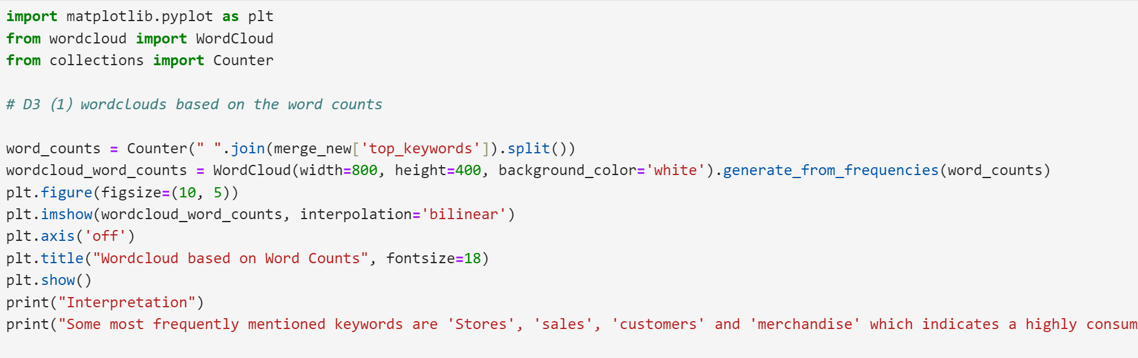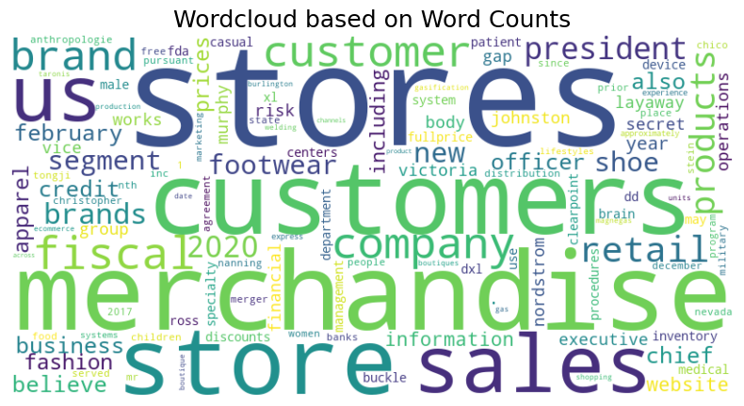

* 1. The most relevant keywords in the apparel industry, relative to others are : 'Stores', 'customers', 'Footwear' and 'brand' which indicates compared to other industries, apparel industry has clearer segmentation based on brands and customers.

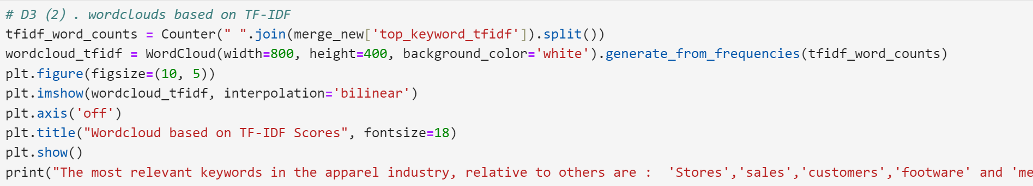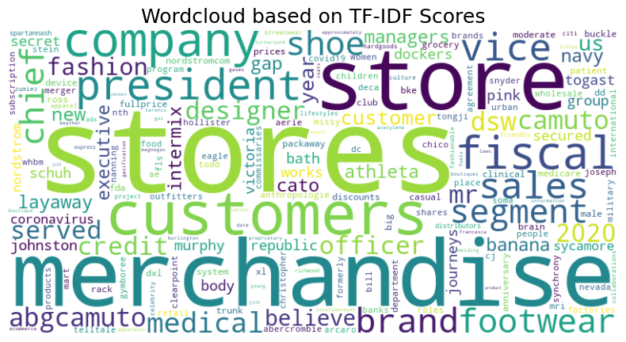

1. Word embedding
   1. We chose the words "Merchandise", "Brand" and "Customers", since they represented the customer centricity of the apparel industry and identified the five most relevant keywords for each term.

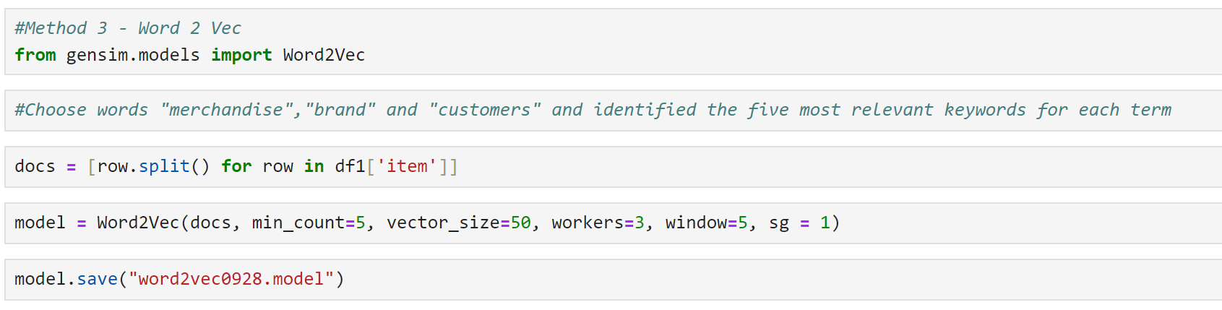

* 1. Top 5 similar words for these industry-related words were:
     1. Merchandise: in season, retailer, stores, assortment, instore

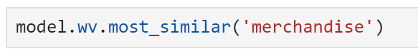

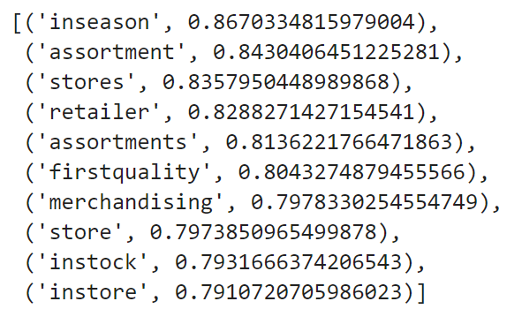

* + 1. Brand: brands, bergio, guess, lee, ugg

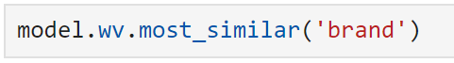

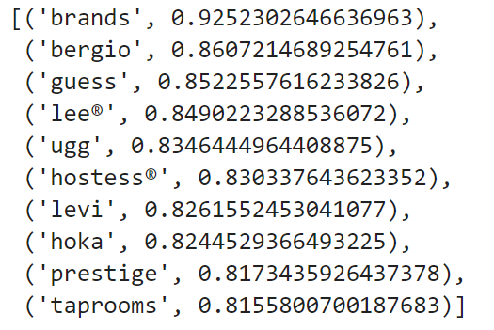

* + 1. Customer: end customer client, customers, enduser, post-sale

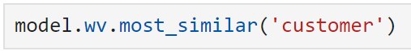

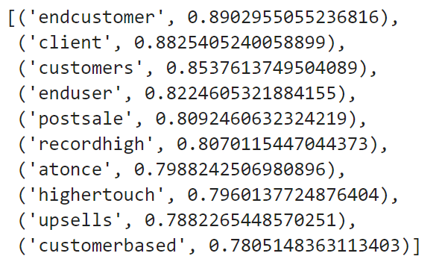

* 1. “Merchandise” and “Customer” are both somewhat interchangeable with the similar words we found based on our model. Interestingly, for the word 'brand', the similar words are the names of the brand.

IV. **Financial Analysis and Operational Suggestions for famous retailer Nordstrom**

1. Analysis background
   1. In this section, we focus on Nordstrom, a well-known luxury department store chain in USA and Canada. As one of the leading retailers in the apparel retail store industry, Nordstrom has built a strong reputation for offering high-end fashion and exceptional customer service. However, like many retailers, it has faced significant challenges, particularly during economic downturns such as the 2008 financial crisis and the pandemic.
   2. Our analysis examines Nordstrom's financial performance, including stock prices, ROA, revenue, and market share. By comparing its key financial indicators with the overall industry and identifying trends, we provide actionable operational suggestions to help the company maintain competitiveness and navigate future challenges.
2. Financial performance

a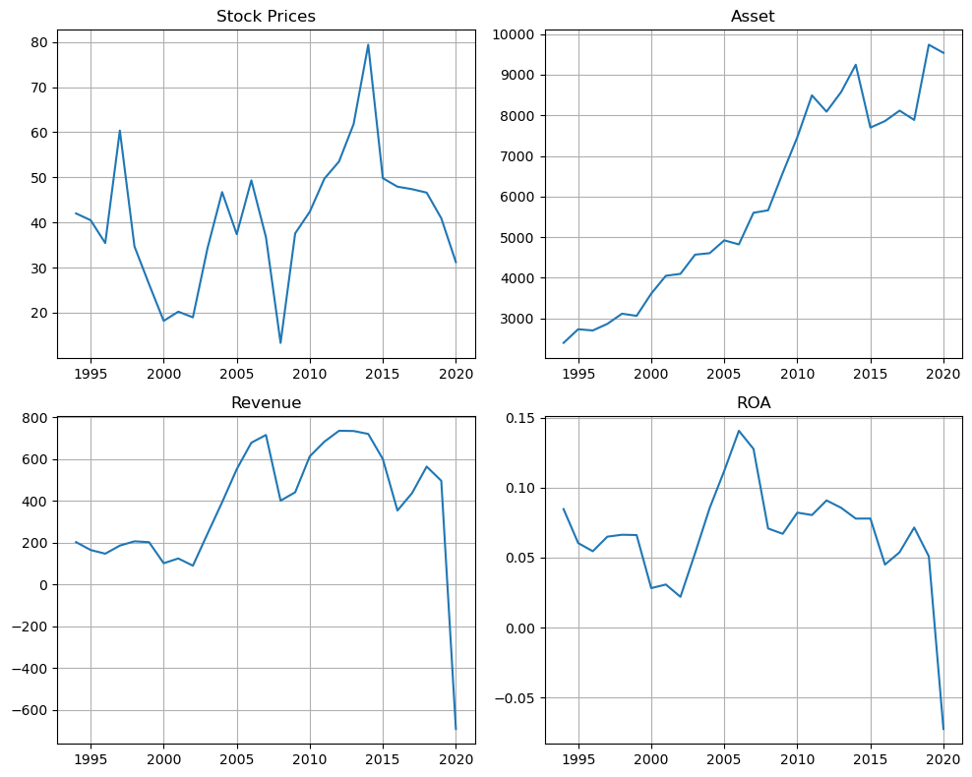

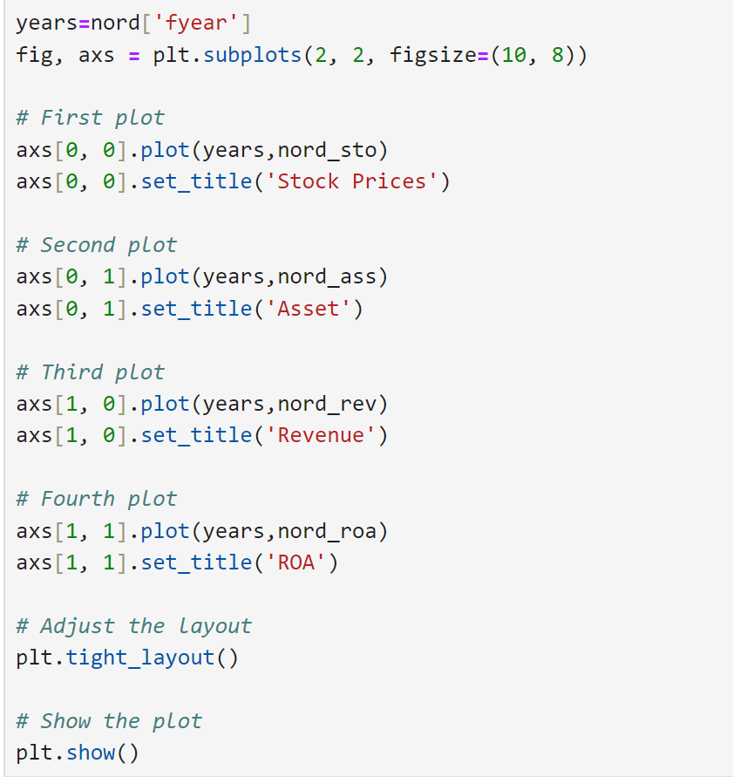

b.Correlation between key metrics

|  |  |  |  |  |
| --- | --- | --- | --- | --- |
|  | Stock price | Net income | Asset | ROA |
| Stock price | 1 | 0.53 | 0.44 | 0.37 |
| Net income | 0.53 | 1 | 0.32 | 0.85 |
| Asset | 0.44 | 0.32 | 1 | -0.13 |
| ROA | 0.37 | 0.85 | -0.13 |  |

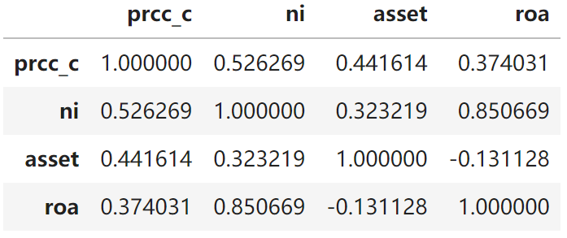

c. The most related variables are net income and ROA which is expected given the formula of ROA

1. **Interpretations and suggestions**
   1. From the graphs, we can see a high potential correlation of revenue with ROA and stock prices. This is why, the ROA and stock prices took a nosedive in 2020 when the revenue was negatively impacted by Covid 19
   2. Therefore, Nordstrom should have been highly revenue focused (i/o cost focused) in the aftermath of the pandemic 2